**Zenecans in Scotland (8th – 12th Sept 2024)**

Our 21st meeting saw the team travelling north to Scotland. The location chosen by the organisers Alastair Aitken and Gary Stoddart was the county of Perthshire. Apologies for absence were received from John Coutts, Bob Noon, Chris Gooderham, Simon Laidler and Geoff Hall (would have been Geoff’s first trip).

As previous organisers will know, finding good accommodation at an affordable price is often the hardest part. Alastair’s wife, Avril, came up with the great idea to select the Red House Hotel in Coupar Angus which was reasonably priced and is close to a vast array of walks and other attractions. It lived up to expectations providing excellent value for money, good food and comfortable accommodation managed by exceptionally friendly staff. The weather behaved itself giving dry days with some sun which was in complete contrast to previous weeks which had seen some very wet and miserable days.

Following tradition, eight early trekkers (Pete Thomas, Ian Stott, Kevin Eddison, Kevin Price, Ray Tucker, Ian Stott, Gary Stoddart and Chris Ursell) arrived on Sunday, 8th May. Much chat and laughter ensued at dinner despite the long day’s travel for most.

Monday morning saw the early trekkers collecting packed lunches and loading walking gear into the cars. The group (minus Kevin Eddison who was still recovering from knee surgery) set off to the Spittal of Glenshee to drop a car before meeting up with the others in the small village of Kirkmichael.

The walk that followed was part of the Cateran Trail which is a well-known circular trail of some 60 miles starting and ending in Blairgowrie. The trail is in the footsteps of the marauding clans and cattle thieves in the days when cattle from the Highlands were driven south in the autumn to be sold. Kirkmichael to Spittal of Glenshee was the chosen section to walk, some 9 miles of mixed terrain including a moorland section with a fairly steep incline (elevation gain for the day was 1561ft) before descending to Spittal of Glenshee.

In front of The Lunch Hut, left to right,: Ian Stott, Pete Thomas, Kevin Price, Ray Tucker, Chris Ursell (Photo Gary Stoddart)

Lunch was appropriately taken at “The Upper Lunch Hut”, used by Queen Victoria in 1865. Sadly, the Spittal of Glenshee Hotel burnt down some 10 years earlier so no refreshments were available at the finish of the walk but refreshments were enjoyed at the Bridge of Cally Hotel on the way back to Coupar Angus.

Upper Lunch Hut, l to r Ian Stott, Peter Thomas, Kevin Price, Ray Tucker, Chris Ursell

Monday evening saw the rest of the team assemble (minus Mike South who joined the group the following morning). As usual John Gray our social member was with us. Mel Codd was welcomed to his first Zenecan Walk experience. Dinner was excellent with fillet steak being the favoured choice. The noise level rose steadily during the evening as everyone caught up with news.

Tuesday morning was chilly and after packed lunches were collected, we left for Ballo car park at the start of the morning’s walk around the Lairds Loch and the Ballo Wood. This was a gentle stroll of some 3.56 miles mostly in woodland but with some good views into Strathmore. Packed lunches were enjoyed sitting in the sun at the edge of the Lairds Loch.

There was a visit in the afternoon to The James Hutton Institute at Invergowrie on the outskirts of Dundee. We were welcomed by Professor Derek Stewart in a brand new multi million pound “Advanced Plant Growth Centre” building. Derek gave us an inspired talk on the Centre which is delivering innovative solutions for food and environmental sustainability. We were lucky enough to be able to enter the modular vertical growth tower (an indoor vertical ecosystem that allows plants and crops to be produced at very high densities in totally controlled environments). On our return, Geoff Coates, who lives close by, joined us for drinks before dinner.

Wednesday saw the group split into the “Leisurely Group” and the “Faster Group”. The leisurely group (Alastair Aitken, Kevin Eddison and Peter Froggatt) left to walk Cargill’s Leap and the Knockie (a 3.75 mile circular walk up the River Ericht and return over the Knockie) on the outskirts of Blairgowrie. The faster group drove to the Cally car park on the outskirts of Dunkeld to walk the Atholl Woods Circuit (approx. 7 miles through forestry, past Mill Dam and returning to the car park through mature woodland overlooking the River Tay.)

The whole group then assembled at The Hermitage (a National Trust for Scotland property close to Dunkeld) for lunch. This was followed by a walk amongst giant Douglas firs to the folly of Ossian’s Hall which overlooks the spectacular Black Linn Falls. Those who felt they needed a bit more exercise carried on for “The Hermitage and Braan Walk” (a 4.25 mile circular walk). Following tradition, dinner was followed by the AGM ably chaired by Kevin Eddison. Peter Rankin delivered some lovely words about the passing of one of our original members this summer, Peter Northwood – glasses were raised in his honour. We also got an update on Tony Moran who is not well. Locations for future walks were agreed with the 2025 walk being the Isle of Wight, organised by Ray Tucker and Kevin Price.

Thursday started with a group photo of us all taken in the car park of the Red House Hotel.

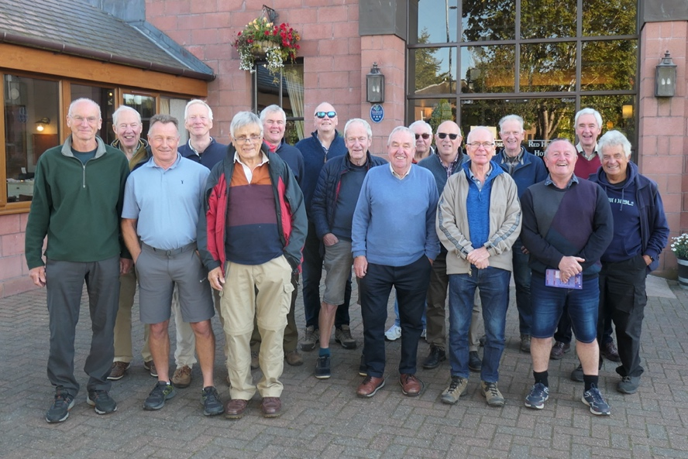

From left to right: Mike South, Gary Stoddart, Martin Frost, Chris Ursell, Peter Froggatt, Peter Rankin, Kevin Eddison, Pete Thomas, Alastair Aitken, John Gray, John Humphreys, Steve Corfield, Kevin Price, Mel Codd ,Ian Stott, Ray Tucker.

Goodbyes from many before a small number drove to Dundee for a fascinating visit to The Verdant Works Museum, part of Dundee’s industrial legacy. An excellent guide showed us around this re-furbished mill building (opened in 1833) which was at the heart of the jute industry. Lunch for some was in the Museum’s café before final goodbyes.

A trip to be remembered for interest, exercise, laughter and good craic. Thanks to all for making it happen.

Gary Stoddart